# ACTIVITIES

EXERCICE 1:

|  |  |
| --- | --- |
| Objective | Take all the apples. |
| Maximum number of instructions | 8 |
| Allowed instructions | GO-UP GO-DOWN GO-LEFT GO-RIGHT PICK-UP REPEAT N-TIME WHILE IF |
| Allowed conditions | <HAS APPLE> |

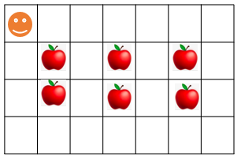

REPEAT<2 TIMES>

Answer:

GO DOWN

WHILE <HAS CELL ON RIGHT>

GO RIGHT

IF <HAS APPLE>

PICK-UP

WHILE <HAS CELL ON LEFT>

GO-LEFT

EXERCICE 2:

|  |  |
| --- | --- |
| Objective | Bring all apples to their respective green box. |
| Maximum number of instructions | 10 |
| Allowed instructions | GO-UP GO-DOWN GO-LEFT GO-RIGHT PICK-UP DROP REPEAT N-TIME WHILE IF |
| Allowed conditions | <HAS APPLE> |

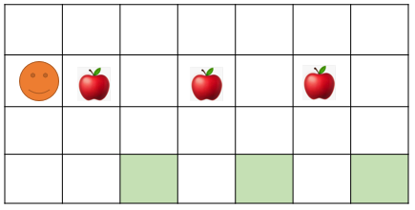

REPEAT <3 TIMES>

Answer:

REPEAT <2 TIMES>

GO RIGHT

IF <HAS APPLE>

PICK UP

DROP

REPEAT <2 TIMES>

GO UP

EXERCICE 3:

|  |  |
| --- | --- |
| Objective | Pick up all apple and stop at the flag!! |
| Maximum number of instructions | 6 |
| Allowed instructions | GO-UP GO-DOWN GO-LEFT GO-RIGHT PICK-UP IF REPEAT N-TIME WHILE |
| Allowed conditions | <HAS APPLE> <HAS FLAG> <HAS **NO** FLAG> |

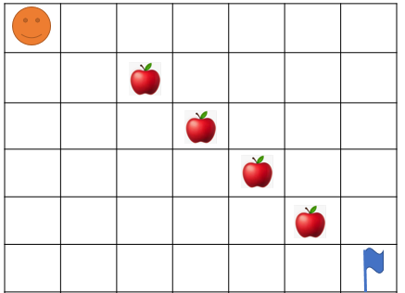

Answer:

REPEAT < 5 TIMES>

GO RIGHT

GO DOWN

IF <HAS APPLE>

PICK UP

EXERCICE 4:

What happen at the end?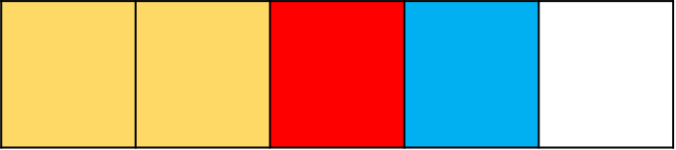

IF

YELLOW

REPEATE 2 TIMES

ELSE

IF

CARROT

EAT CARROT

ELSE

IF

ELIF

EAT BANANA

IF

RED​ **OR** BANANA

GO FORWARD

ELSE

* How many carrots Jack eats ?

Jack eats 1 carrots

* How many bananas Jack eats?

No bananas Jack eats

* Where will be Jack at the end?

At the end Jacks will be at the second

Yellow cell.



GO FORWARD

GREEN

GO FORWARD

BLUE

EAT BANANA

ELSE

GO LEFT

EXERCICE 5:

|  |  |
| --- | --- |
| Objective | Bring all apple to green box and stop at the flag!!  WARNING : you program must work for the 2 cases !!! |
| Maximum number of instructions | 10 |
| Allowed instructions | GO-UP GO-DOWN GO-LEFT GO-RIGHT PICK-UP DROP IF REPEAT N-TIME WHILE |
| Allowed conditions | <HAS APPLE> <HAS CELL DOWN>  <HAS FLAG> <HAS **NO** FLAG> |

Case1: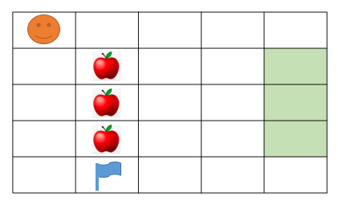

Be careful NOT to pick up the flag

=

WHILE <HAS NO FLAG>

GO DOWN

Case 2: 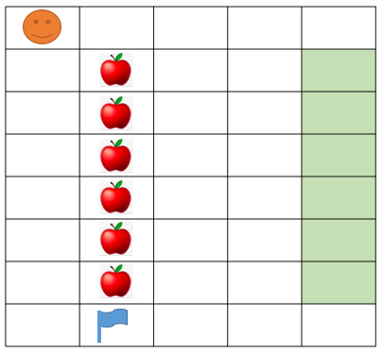

REPEAT<4TIMES>

GO RIGHT

IF <HAS APPLE>

PICK UP

DROP

REPEAT <5 TIMES>

GO LEFT

Answer:

IF <HAS FLAG>

STOP

EXERCICE 6:

|  |  |
| --- | --- |
| Objective | Take all the apple to green box  WARNING: you program must work for the 2 cases!!! |
| Maximum number of instructions | 15 |
| Allowed instructions | GO-UP GO-DOWN GO-LEFT GO-RIGHT PICK-UP DROP IF REPEAT N-TIME WHILE |
| Allowed conditions | <HAS APPLE> <HAS CELL ON RIGHT>  <HAS CELL ON LEFT> |

**Case 1:**

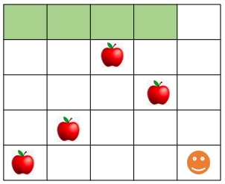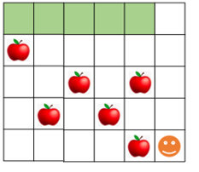

**Case 2:**

WHILE <HAS CELL ON LEFT>

Answer:

GO <LEFT>

REPEAT<4TIMES>

IF<HAS APPLE>

PICK UP

GO UP

DROP

REPEAT<4TIMES>

GO DOWN

EXERCICE 7:

|  |  |
| --- | --- |
| Objective | Take all the apple |
| Maximum number of instructions | 8 |
| Allowed instructions | GO-UP GO-DOWN GO-LEFT GO-RIGHT PICK-UP DROP  IF  REPEAT N-TIME WHILE |

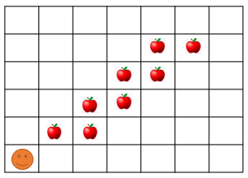

Answer:

GO RIGHT

REPEAT<4 TIMES>

GO UP

PICK UP

GO RIGHT

PICK UP

EXERCICE 8:

|  |  |
| --- | --- |
| Objective | Take all the apple and go to the green cell |
| Maximum number of instructions | 11 |
| Allowed instructions | GO-UP GO-DOWN GO-RIGHT PICK-UP  IF  REPEAT N-TIME WHILE |

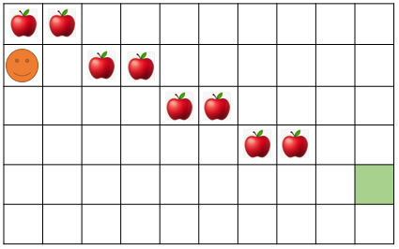

REPEAT<5 TIMES>

Answer:

GO UP

IF<HAS APPPLE>

PICK UP

GO RIGHT

IF<HAS APPPLE>

PICK UP

REPEAT<2 TIMES>

GO DOWN

GO RIGHT

EXERCICE 9:

|  |  |
| --- | --- |
| Objective | Bring all apples put in the black cell and go to the green cell.  **Note**: your program must work for the 2 cases!!! |
| Maximum number of instructions | 10 |
| Allowed instructions | GO-UP GO-DOWN DROP GO-RIGHT PICK-UP  IF  REPEAT N-TIME WHILE |
| Allowed conditions | <HAS APPLE> <HAS CELL ON RIGHT>  <HAS CELL ON LEFT> <HAS CELL ON UP> |

Case 1

Case 2

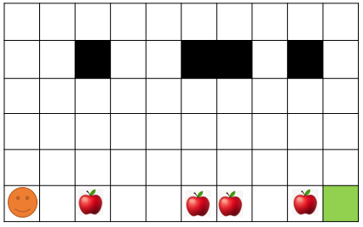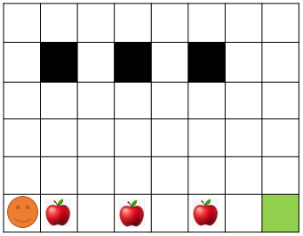

While<has cell on right>

Answer:

Go right

IF<has apple>

Pick up

Go down

Repeat 4 times

Drop

Go up

Repeat 4 times